Type of Website:

Portfolio

Name of Website:

Miller Design

Home

Text on home page:

Meet Charles, a hardworking and enthusiastic web developer who is passionate about developing unique and attractive web environments. Fascinated by the design and visual implementations of applications. Nearly obsessive until projects are complete to ensure efficiency but with great attention to detail. Experience with many languages. Goal driven and constantly learning current and new languages.

Contact Me

Email: [charles.miller.0412@gmail.com](mailto:charles.miller.0412@gmail.com)

LinedIn: <https://www.linkedin.com/in/charlesmiller0412/>

GitHub: <https://github.com/charlesmiller0412>

Quote Form

First Name

Last Name

Phone number

Email

Preferred method of contact? (radio) Email (radio) Phone

Time:

Date:

Type of service: (radio) Web (radio) Graphic (radio) Application

Describe what you are hoping the finished product would be:

Services

Web design and development

Graphic design

Application development

Available coding language support: HTML5, CSS3, Bootstrap, JavaScript, Java, Python, and C#.

Web Design

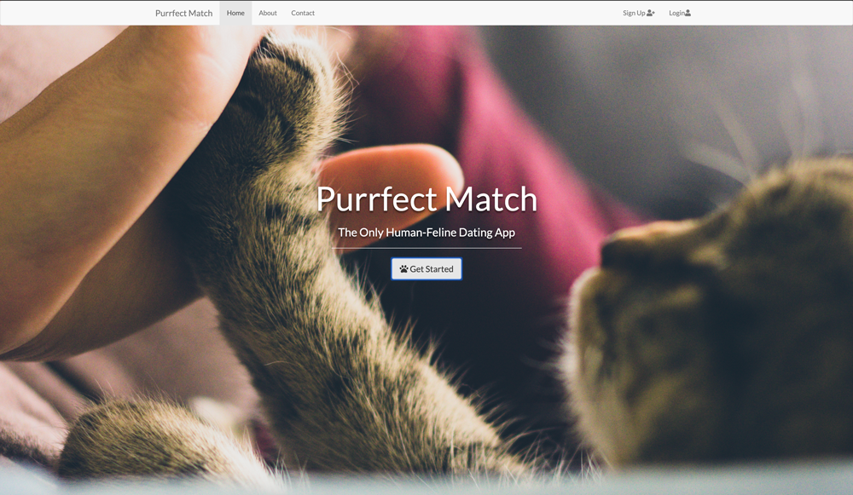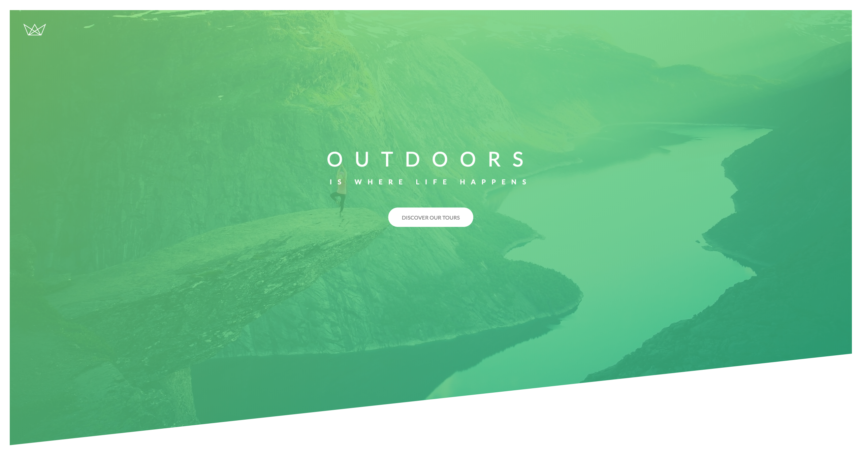

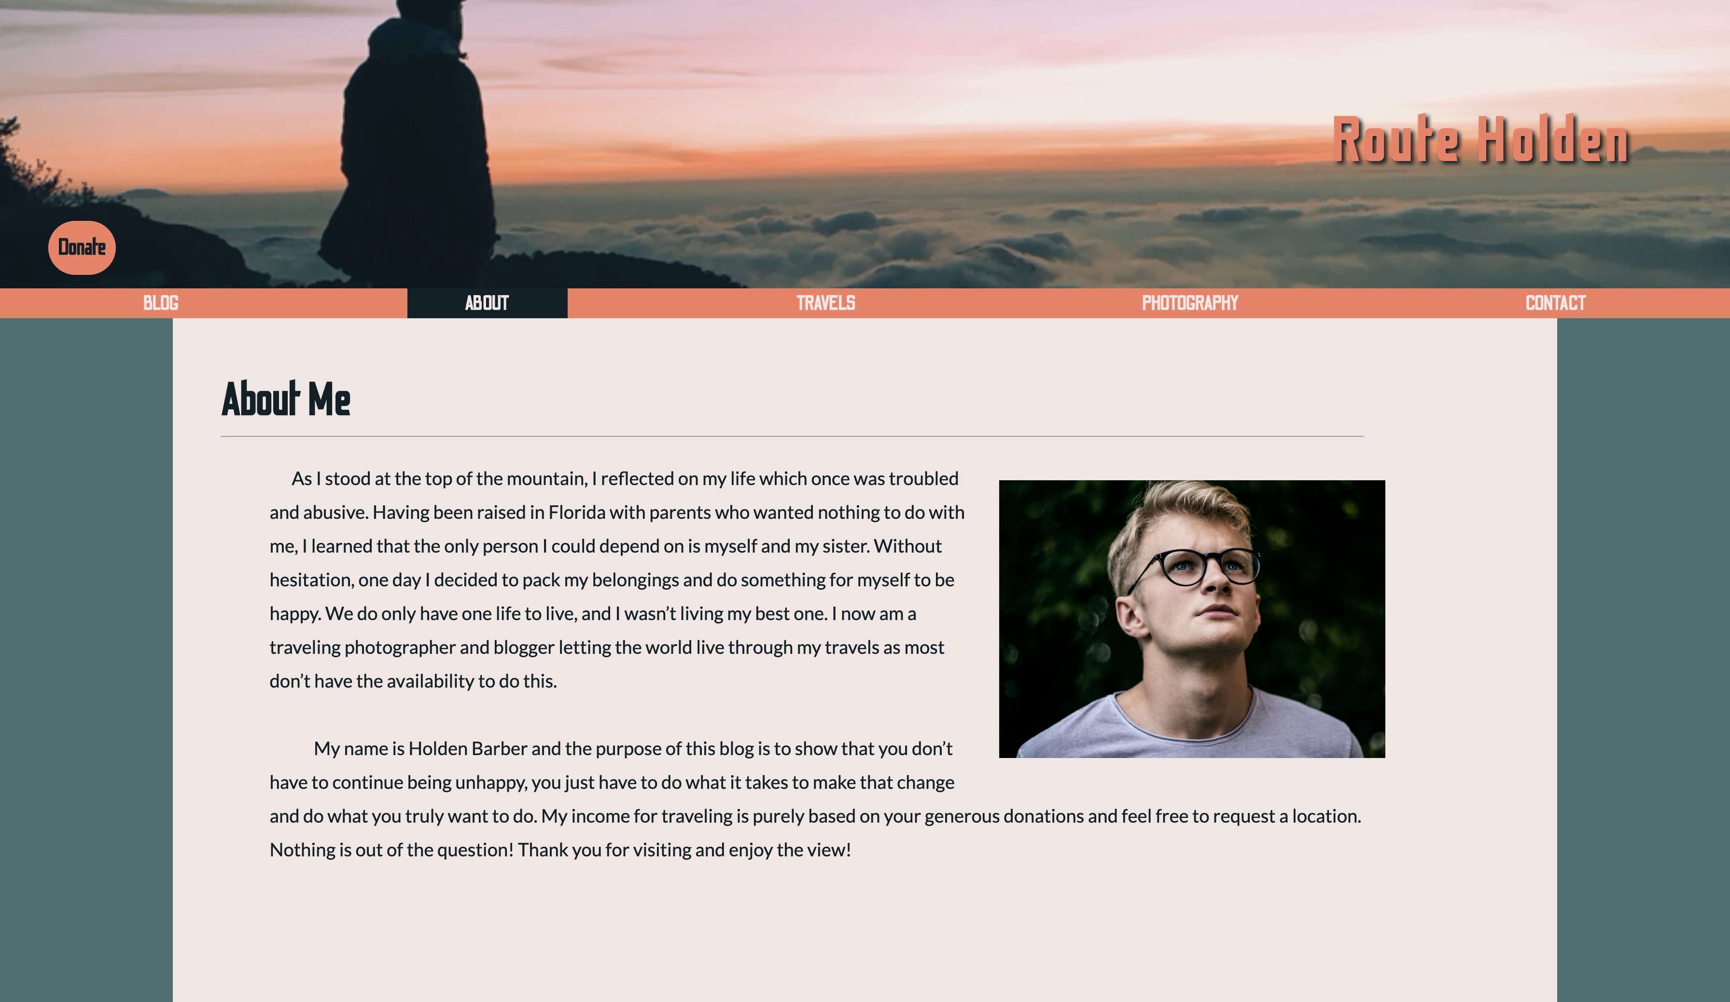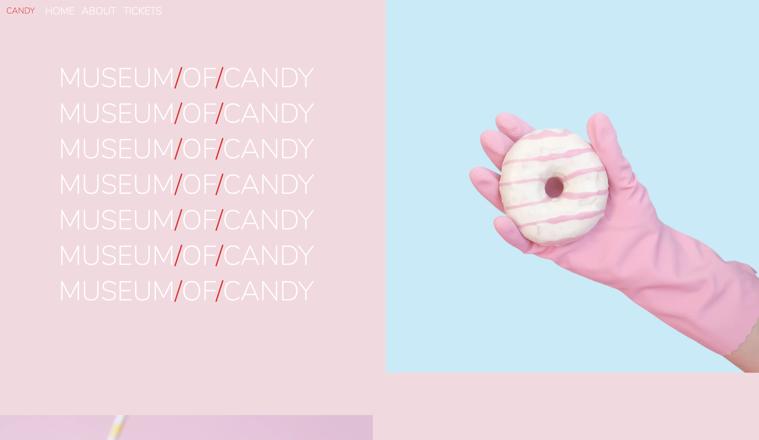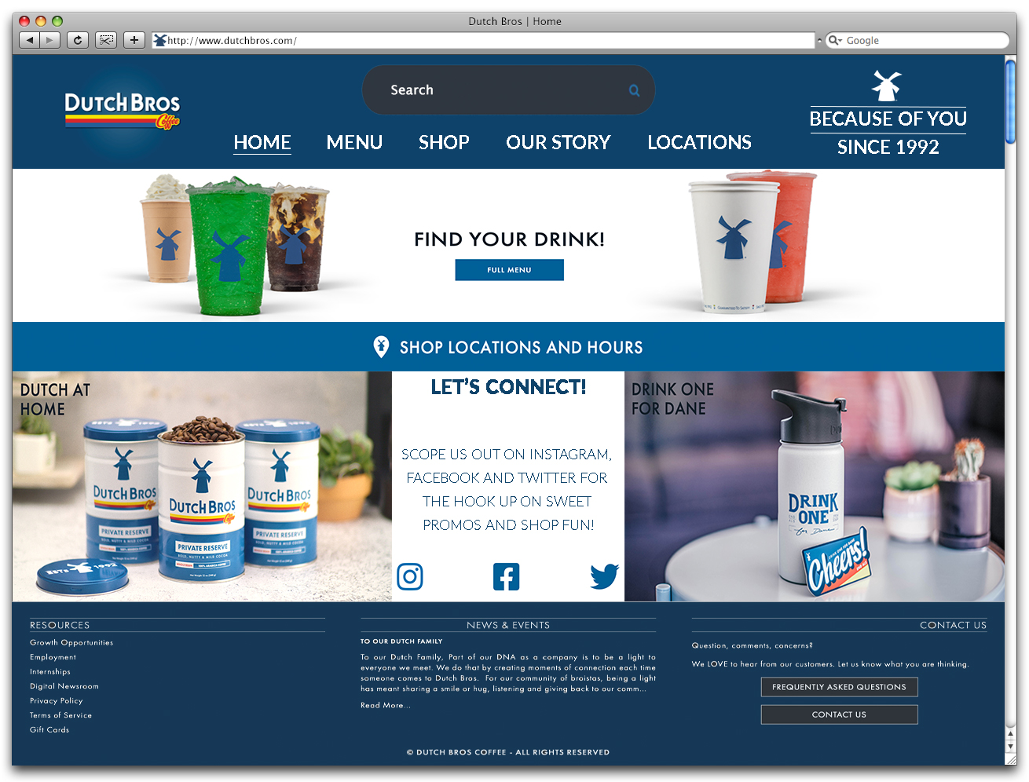

Graphic Design

